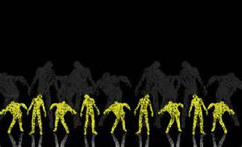

ZOMBIE PISTOL SHOOT
Wednesday, October 16th at Manteca Sportsmen
Zombie eradication starts at 5:30 and ends at 9:30.
Zombie killer admission is $10.00 and requires at least 40 rounds of ammunition.
Various paper and reactive zombies.
Multiple magazines and magazine pouch helpful.
No holsters.
RSVP on Manteca Sportsmen blog or Facebook page.

